**Time Series Database Partitioning Documentation**

**Overview**

This document describes the implementation of a partitioned database table for storing daily foreign exchange rates data from 1979 to 1998. The solution leverages PostgreSQL's table partitioning feature to optimize data management and query performance.

**Database Schema**

**Parent Table Structure**

***CREATE TABLE fx_rates (***

***date date NOT NULL,***

***rate numeric(10,3) NOT NULL***

***) PARTITION BY RANGE (date);***

This parent table defines the structure for all partitions and specifies that partitioning will be by date range.

**Partition Creation**

**Yearly Partition Implementation**

* The following PL/pgSQL block creates individual partitions for each year from 1979 to 1998:

***DO $$***

***DECLARE***

***yr int;***

***BEGIN***

***FOR yr IN 1979..1998 LOOP***

***EXECUTE format($fmt$***

***CREATE TABLE fx_rates_%1$s***

***PARTITION OF fx_rates***

***FOR VALUES FROM ('%1$s-01-01') TO ('%1$s-12-31');***

***$fmt$, yr);***

***END LOOP;***

***END $$;***

This creates 20 partitions (one for each year) with names following the pattern fx_rates_YYYY.

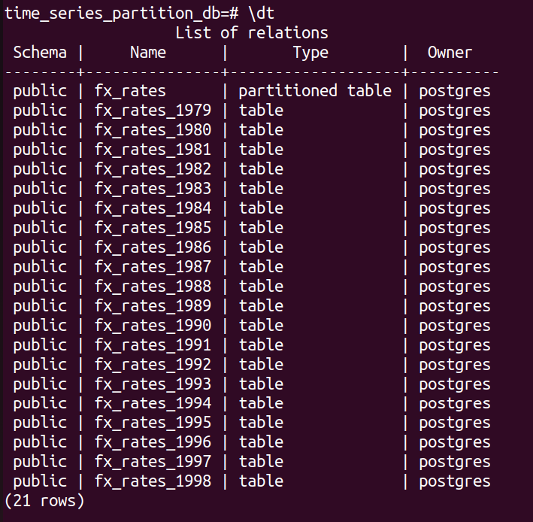

**Performance Optimization**

**Index Creation**

* To improve query performance on rate-based operations, an index was added:

***CREATE INDEX ON fx_rates (rate);***

* This index supports efficient filtering and sorting operations on the exchange rate values.

**Data Loading**

**Import Process**

Data was loaded from an Excel file (converted to CSV format) using PostgreSQL's \copy command:

***\copy fx_rates(date, rate)***

***FROM '/home/main/Downloads/daily-foreign-exchange-rates-31-.xlsx'***

***WITH CSV HEADER;***

**Note:** The Excel file was pre-processed by removing the last row which contained non-data information.

**Verification**

**Partition Data Distribution Check**

To validate that data was correctly routed to the appropriate partitions:

***SELECT***

***tableoid::regclass AS partition,***

***COUNT(*) AS rows***

***FROM fx_rates***

***GROUP BY 1***

***ORDER BY 1;***

This query confirms the row count distribution across all partitions.

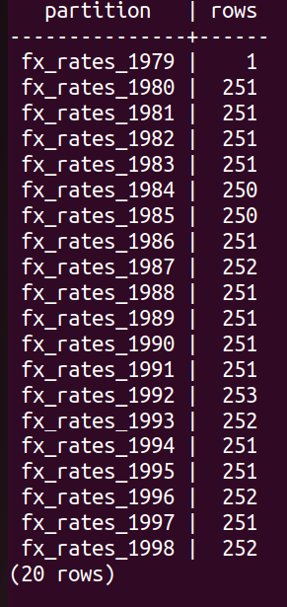

**Implementation Notes**

* Partitioning Strategy: Yearly range partitioning was chosen as it aligns with typical time-series analysis patterns and provides good performance for date-range queries.
* Data Preparation: The source Excel file was converted to CSV format and cleaned by removing non-data rows before import.
* Performance Considerations: The rate column index was added after partition creation to ensure it applies to all partitions.